

**University Of Petroleum and Energy Studies,**

**Dehradun**



**Cloud Application Development**

**(Theory)**

**Submitted by:**

Name- Ashutosh Lodha

SAP: 500087620

Enrolment No. : R2142201876

CCVT batch: B4

**Submitted To:**

Prof. Saurabh Shanu

**Concept Note**

**Project Title:** Creating a Video conferencing Web-Application and deploying it over cloud.

**Usage of cloud in this project:**

## Scalability: Cloud servers can easily handle large numbers of users and provide additional resources on demand.

## Reliability: Cloud infrastructure provides consistent and reliable performance, ensuring smooth video conferencing experiences.

## Cost-effectiveness: Running a video conferencing system on the cloud eliminates the need for expensive hardware and IT infrastructure.

## Accessibility: Cloud-based video conferencing apps can be accessed from anywhere with an internet connection, enabling remote work and collaboration.

## Security: Cloud providers typically have robust security measures in place to protect data and ensure privacy

**Theory**

**Literature review:**

1. **<https://www.ncbi.nlm.nih.gov/pmc/articles/PMC4432776/>**

**This review compares traditional videoconferencing systems with cloud-based videoconferencing systems. It highlights the differences between the two and explains the methods used to evaluate them. The results suggest that the technology is evolving rapidly and hands-on experience is necessary to fully assess the relevance of cloud conferencing technology. The review provides a template for evaluating the appropriateness of systems. It distinguishes cloud videoconferencing from traditional videoconferencing by explaining the key difference of client conferencing software accessing videoconferencing software on servers in the cloud. Traditional videoconferencing is done through installed appliances in a room and uses the H.323 communication standard for interoperability. The review also mentions terms related to cloud conferencing such as WebRTC, unified communication, and video as a service. The purpose of the review is to provide a framework for assessing cloud videoconferencing in relation to local needs and to determine if migration from traditional to cloud systems is justified. The findings show that cloud videoconferencing systems are characterized by several key features, including video and audio encoding, multipoint conferencing, compatibility with different operating systems and computing platforms, interoperability, security, content sharing, user-friendly interfaces, archiving capabilities, and Webcasting options. The results of the review suggest that cloud-based videoconferencing systems offer several advantages over traditional systems, including increased flexibility, scalability, and ease of use.**

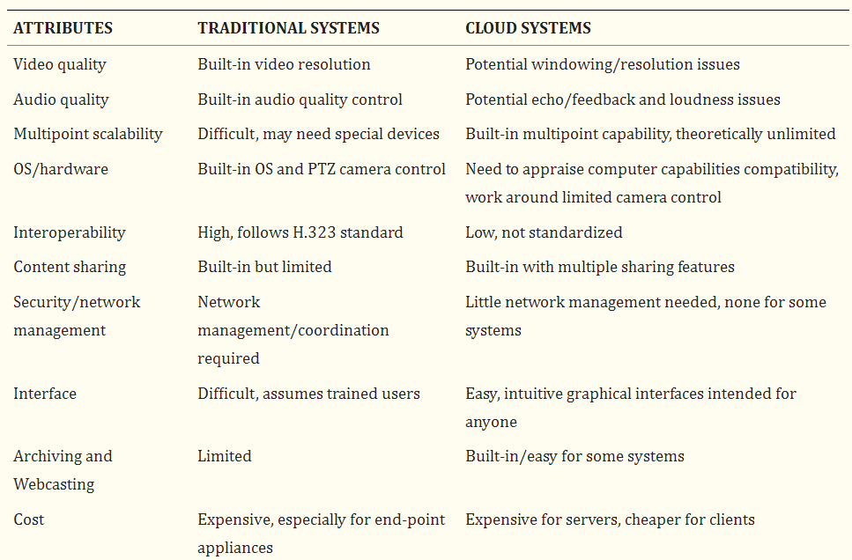

**Source:** <https://www.ncbi.nlm.nih.gov/pmc/articles/PMC4432776/>

1. [**https://www.frontiersin.org/articles/10.3389/feduc.2021.752522/full**](https://www.frontiersin.org/articles/10.3389/feduc.2021.752522/full)

**The COVID-19 pandemic has led to a decrease in physical interaction and an increase in the adoption of e-conferencing for conducting business globally. The virtualization of meetings promotes collaboration and helps meet the goals of organizations. Web conferencing has proven to be beneficial in the education sector, allowing higher learning institutions to expand access to instructors online while also creating new learning experiences. The study describes the use of web conferencing in education, its adoption and influence on teaching and learning, the benefits and disadvantages, and provides examples of two web-conferencing platforms (Zoom and Google Meet). The future of web-conferencing in education is also discussed. Web conferencing is a tool for virtual meetings, presentations, and collaborations that allows for real-time video content to be shared with a large group through the Internet. In Thailand, the government passed regulations in 2014 allowing for secure online meetings through electronic devices. Thailand has embraced online learning and has personalized, facilitative, and responsive education through technology. The adoption of information and technological systems, like web conferencing, benefit the education field by allowing for easy access to data and improving collaboration. Collaboration is important in education and is essential for the success of an organization. Investment in collaboration technology and a supportive culture is necessary to realize meaningful collaboration. There are various tools, like e-mail, audio, and video conferencing, available to aid in the collaborative learning process.**

1. [**https://iopscience.iop.org/article/10.1088/1742-6596/1679/3/032078/pdf**](https://iopscience.iop.org/article/10.1088/1742-6596/1679/3/032078/pdf)

**The widespread use of technology has led to the popularization of cloud computing and cloud services. Distributed cloud video conferencing technology provides easily scalable computing resources and allows for the delivery of infrastructures, platforms, and applications as services, benefiting many users including businesses. Cloud computing reduces the total cost of ownership of IT infrastructure, increases its fault tolerance, allows access to data from almost any device through the internet, and has high elasticity.**

**One of the most popular cloud services is video conferencing, which has become increasingly important as remote work and remote collaboration have become more prevalent. Currently, there are several companies offering video conferencing services such as Cisco, Zoom, Microsoft, and LogMeIn.**

**Video conferencing technology can be classified into three types: hardware, software, and cloud. Cloud video conferencing is currently the most popular type. The quality of video communication is an important aspect of video conferencing and users expect improvements in this area, as well as increased integration with other information systems, applications, and services. The increasing demand for video conferencing and the limitations of existing services make it necessary to develop a new, distributed cloud video conferencing service.**

**The authors of the paper have developed a distributed cloud video conferencing service for use in the higher education system. The service's architecture is based on 5 types of servers: an application server, a database server, a mail server, a web socket server and SDN control servers. The network infrastructure is built on SDN technology, allowing for effective interaction between servers and management of video data streams. The proposed approach has been found to be effective in higher education and related fields.**

1. **Measurement Study of Multi-party Video Conferencing Yue Lu, Yong Zhao, Fernando Kuipers, and Piet Van Mieghem**

**This paper explores the rise in telecommuting and video conferencing due to COVID-19 restrictions on mass gatherings and social distancing, as well as the potential cyber security risks posed by these technologies. The paper provides a comprehensive overview of the vulnerabilities, threats, and impacts of cyber-attacks related to telecommuting and video conferencing. The paper is divided into five sections: Introduction, Components of telecommuting and video conferencing applications, Challenges of remote work and their cyber security implications, Business and technical impacts of WFH-based cyber-attacks.**

**The shift to WFH has brought about several challenges from a technological, cybersecurity, and philosophical perspective. Technologically, there are several challenges to consider, including employee's role in the organization, their access to company assets, psychological balance to work alone, IT security awareness, the reliability of technology, and the convenience of the remote working environment. Geography also plays a role, with some regions having access to reliable internet services while others face issues with power supply and bandwidth. Additionally, working from home could also lead to data errors from distractions like household chores and personal emailing. Cybersecurity risks include insecure networks, poor network conditions, and inadequate bandwidth, which could lead to cyber attacks on remote communication systems. The paper is about the investigation and analysis of the characteristics and quality of experience of four representative multi-party video conferencing applications. The aim of the study is to answer questions about how these applications work, what resources they need, what the Quality of Experience (QoE) is, what the bottleneck is in providing multi-party video conferencing over the internet, and what technology and architecture offer the best QoE. The study surveyed 18 popular video conferencing applications and chose four representative ones to measure, including Mebeam, Qnext, Vsee, and Nefsis.**

1. [**https://dl.acm.org/doi/pdf/10.1145/3487552.3487842**](https://dl.acm.org/doi/pdf/10.1145/3487552.3487842)

**This passage describes the results of a study on three modern video conferencing applications (VCAs): Zoom, Google Meet, and Microsoft Teams. The study aimed to understand the resource requirements and performance of these VCAs under different network conditions. The study found that the average utilization of an unconstrained link varied between 0.8 Mbps and 1.9 Mbps, and some VCAs required up to 50 seconds to recover to steady state after temporary reductions in capacity. The study also found differences in proprietary congestion control algorithms that result in unfair bandwidth allocations. For example, one Zoom video conference can consume more than 75% of the available bandwidth when competing with another VCA. The study also found that the utilization of some VCAs decreased as the number of participants increased, and that the viewing mode of one participant can affect the upstream utilization of other participants.**

**This paper is motivated by the increasing reliance on video conferencing applications (VCAs) due to the COVID-19 pandemic, which has highlighted disparities in internet access for remote education and work. The authors aim to answer questions about the network requirements for VCAs, including their network utilization, performance under different link capacities, response to disruptions, competition with other applications, and the effect of usage modalities on network utilization. The authors perform controlled experiments with emulated network conditions and collect data using APIs. Their findings have implications for network management and policy, including questions about the throughput needed to support quality video conferencing.**

1. **Central European Journal of Educational Research 2(2) 2020. 84–92.**

**Germann et al. analyzed the possibility of remote teaching during a pandemic, and Faherty et al. explored the preparedness of schools for such a situation. Online learning rearranges the world of homework and exams, but it also poses challenges such as the need for new technologies to avoid cheating and the possibility of a student lacking access to the tools necessary for online education. Social disparities increase with distance education and students without access to education face serious long-term problems, including a reduced chance of meeting year-end requirements, increased chances of dropping out, and permanent disadvantage.**

**Video conferencing allows real-time transmission and reception of audio and video data over a network between users who are at a distance from each other. Skype and Zoom are popular videoconferencing tools used for teleconferencing, telecommuting, distance learning, and social networking. Skype is free for users for calls inside the app and can be used for instant messaging, voice and video communication, and conference calls. Zoom, on the other hand, has a user-friendly interface and offers face-to-face chat, group video conferencing, screen sharing, recording appointments, etc. Zoom's use is free for up to 100 participants and has a time limit of 40 minutes for calls with more than two people. Paid subscriptions are available for longer or larger conferences. Zoom experienced a huge increase in users during the COVID-19 pandemic due to the exponential growth of teleworking and distance learning.**

1. [**https://doisrpska.nub.rs/index.php/JTTTP/article/view/6562/6430**](https://doisrpska.nub.rs/index.php/JTTTP/article/view/6562/6430)

**Video conferencing has become an essential tool for various fields including business, education, health, and others. It provides a way for students to communicate with each other and teachers through synchronous two-way audio and video over the internet. This type of technology expands traditional teaching methods by allowing the use of digital images and videos. Video conferencing enables distance education and can reach new target groups, making education more flexible and accessible. The use of video conferencing has been facilitated by the growth of internet services and is considered a critical component of e-learning technology.**

**Flowchart:**

**Stage 1: Gathering Relevant Information**

* **Gathering information about the previous research work done**
* **Gathering information about the technologies required**

**Stage 2: Planning: Sitemap and Wireframe**

* **Designing the basic layout(wireframe) of the webapp for video conferencing**
* **Laying out the basic structure for components on each page**

**Stage 3: Design**

* **Designing the layout of the pages, the colour schemes etc.**

**Stage 4: Development**

* **Writing code for each component as per planned with repetitive steps of coding and unit testing for getting the desired layout of the page.**
* **Writing various file like app.js etc to provide the desired functionality**

**Stage 5: Testing, Review, and Launch**

* **After the code has been developed the final webapp is tested and reviewed to ensure a successful launch**
* **Deploying the webapp over openstack cloud.**

**Stage 6: Monitoring and maintenance**

* **Collect feedback and make changes as per requirement**

**General flowchart for a video conferencing app:**

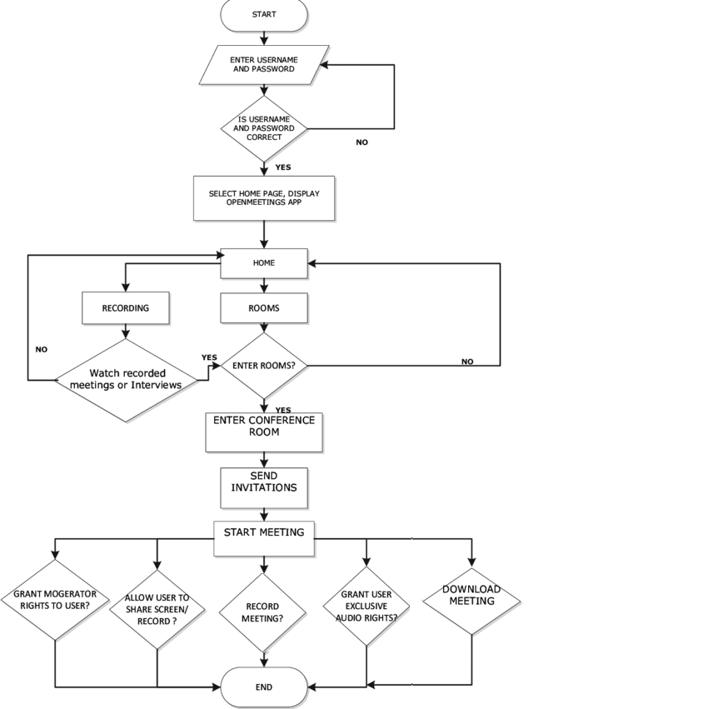

Source: <https://www.researchgate.net/figure/Flow-Chart-Diagram-for-OpenMeetings_fig3_307856798>

**Hosting video conferencing web-app on AWS cloud:**

Hosting a video conferencing web application on Amazon Web Services (AWS) is possible, and there are several options available. Following are a few steps and services to consider when hosting a video conferencing application on AWS:

1. **Choose an AWS instance type:** Choose an AWS instance type with the necessary processing power and memory to handle the demands of a video conferencing application. Consider using instances with dedicated GPU or FPGA for better video processing capabilities.
2. **Set up a web server:** You can use Amazon Elastic Compute Cloud (Amazon EC2) to host a web server for your video conferencing application. You can use an Amazon Machine Image (AMI) that includes a web server and web application framework, such as Amazon Linux, Ubuntu, or Windows.
3. **Amazon S3 for storage:** You can use Amazon Simple Storage Service (Amazon S3) to store video data and files related to the video conferencing application.
4. **Amazon CloudFront for content delivery:** You can use Amazon CloudFront, a content delivery network (CDN), to deliver video content to users more quickly and efficiently.
5. **Amazon CloudWatch to monitor performance:** You can use Amazon CloudWatch to monitor the performance of your video conferencing application and receive alerts if any issues arise.
6. **Amazon Chime**: If you need a full-featured, managed video conferencing solution, consider using Amazon Chime. Amazon Chime provides audio, video, and screen-sharing capabilities, and supports up to 100 participants in a single meeting.
7. **Route 53:** AWS Route 53 may be used to host the web-app with a domain. Amazon Route 53 is a highly available and scalable Domain Name System (DNS) web service offered by Amazon Web Services (AWS). Route 53 provides domain name registration and routing for internet applications, enabling you to translate human-readable domain names into IP addresses. This service allows you to manage your domain names and route traffic to your applications, whether they're hosted on AWS or elsewhere.

By using AWS, we can take advantage of the **scalability, security, and reliability** of the AWS Cloud, and **focus on building and deploying** your video conferencing application, rather than managing the underlying infrastructure.